Setting up Rakwireless Gateway and migrating it to V3 (The Things Stack)

**RAK 7243** and **RAK7244 C** works the same. Both are powerful multi channel gateway with LTE feature.

We are going to focus on how to set up this type of gateway upto having them on The things Stack (V3) network.

**What do you need ?**

* Rak7243/ Rak7244C gateway
* 16gb SD card and above.
* 5v Power supply 2.5A (We recommend raspberry pi charger)
* Sd Card reader.
* Raspberry Pi Imager
* Putty software (Download the one suiting your OS)
* PC
* Internet connection

1. Download the Rak7243 gateway firmware (<https://downloads.rakwireless.com/LoRa/Pilot-Gateway-Pro-RAK7243/Firmware/>). While finished downloading, unzip the firmware to a folder of your choice.

2. Download the raspberry pi Imager (<https://downloads.raspberrypi.org/imager/imager_latest.exe>.

3. Install and run the Raspberry pi imager to be able to burn the firmware to the SD card.

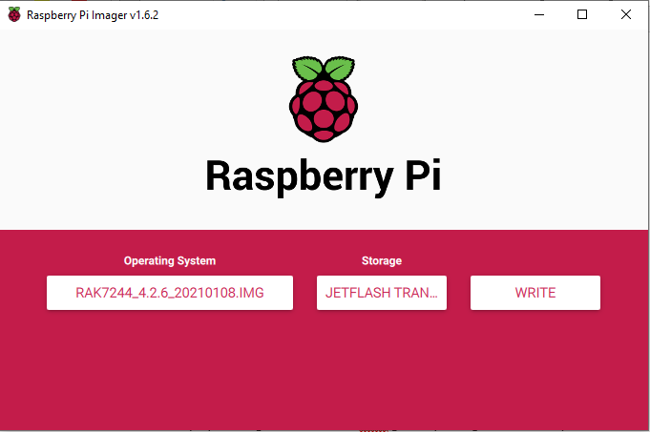

4. Insert your SD card in the SD card holder and then to your pc. Use One of the Raspberry Image feature to format your SD card.

5. Connect the antennas of the gateway as indicated here.

Top right – connect GPS antenna

Top Left – LoRa 868 antenna

Bottom Left and Botton right – LTE antenna.

6. After success formating procedure, choose the downloaded image then write it to your SD card.

Power the gateway and wait till the gateway completes to boot. ( for the first time the gateway will take time. )

7. After the gateway is up, it will create its own hotspot. This allows you to connect to the gateway locally and do confurations.

Connect to the hotspot using **rakwireless** as the password.

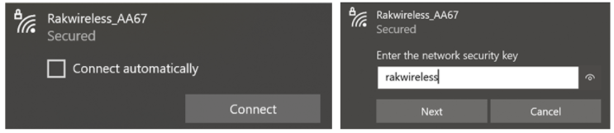

8. Download Putty and install it. Using putty connect to your gateway remotely.

The default IP is 192.168.230.1.

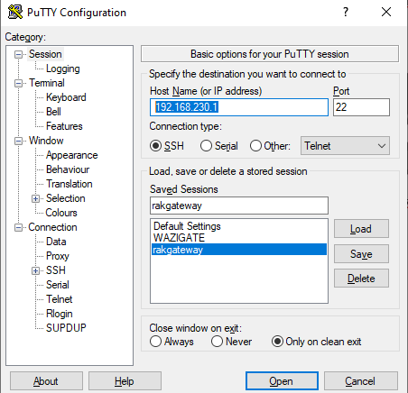

9. The next step is connecting the gateway to a local internet (Wireless one)

After clicking the open button of Raspberry pi. Login to your device using the following default credentials.

Username > pi

Password >raspberry

Run the command *sudo raspi-config*

